

MICROSTRATEGY

Version 0.1

How to use Micro Strategy

Prepared For: DATA MANAGEMENT TEAM

Prepared By: HARKIRAT GHOTRA (CO-OP STUDENT)

Date: 2016-31-03

**Document Purpose**

The main goal of the document is to allow our ITBS team to understand the purpose of the Micro Strategy, and develop graphs to analyse the performance of Netezza box.

Where possible, the document will include:

1. Micro Strategy Desktop
2. Micro Strategy Web

**Table of Contents**

1. Introduction 4

2. Important definations 5

3. MicroStrategy Desktop 6

4. MicroStrategy Web 16

**INTRODUCTION**

Micro Strategy is an enterprise business intelligence application software vendor, which supports interactive dashboard, scorecards and highly formatted reports.

Here we are using two things, one is Micro Strategy Desktop and other one is Micro Strategy Web.

**Micro Strategy Desktop**

It is a developer tool, which is used to create attributes, facts, metrics, filters and reports.

**Micro Strategy Web**

Micro Strategy Web is used to create dashboard with the help of using report from Micro Strategy desktop.

**Important definitions**

The following are important definitions, which will help in creating the reports:

1. Attributes – Attributes provide a context in which to report on and analyze business facts or calculations. For example we can create attributes like “region”, “states” or “year”, so we can define which states in which year how much revenue or profit one company has.
2. Facts – Facts are the numerical value, which are used to form a metrics.
3. Metrics – Metrics are used to perform the calculation. For example: we can use Metrics to calculate the profit or loss. Metrics are similar to formulas which give us useful results.
4. Filters – A filter is the part of a Micro Strategy report to determine whether the data should be included in or excluded from the calculations of the report results.

**Micro Strategy Desktop**

It’s a developer tool, where we can create project, reports, attributes, fact and metrics.

Steps to follow for using Micro Strategy Desktop:

1. Get an access from Admin

* First of all, get an access from ADMIN for Micro Strategy Desktop, he will set you up for remote desktop connection. In my case, Jennifer Lamb helped me to get all access for Micro Strategy.
* While making the dashboard, I got all access from John Lauro, he is a BI production Specialist, who provided me all access. Because in Micro Strategy, we don’t have full privilege to use folder or to create project. For that we need to contact him, his email address is [John_Lauro@cooperators.ca](mailto:John_Lauro@cooperators.ca)
* For any request in MicroStrategy, just create incident and explain that you don’t have access to particular folder and assign to John Lauro and then he will set up for that. For example, if you want to create a project then error message will appear, which will say that “you don’t have privilege for creating project”. So in that case contact ADMIN
* Go to the start menu, and then click on remote desktop connection.

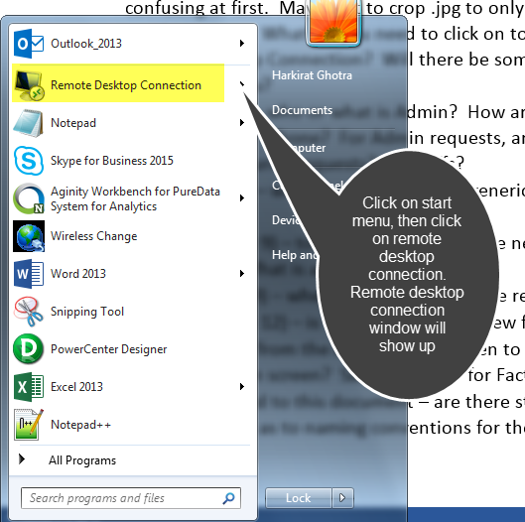

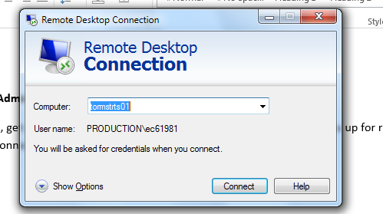

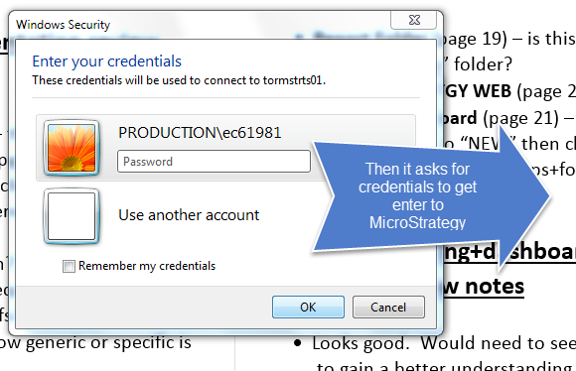

* Once, you get connected, the different server will open and there you can click on Micro Strategy desktop.

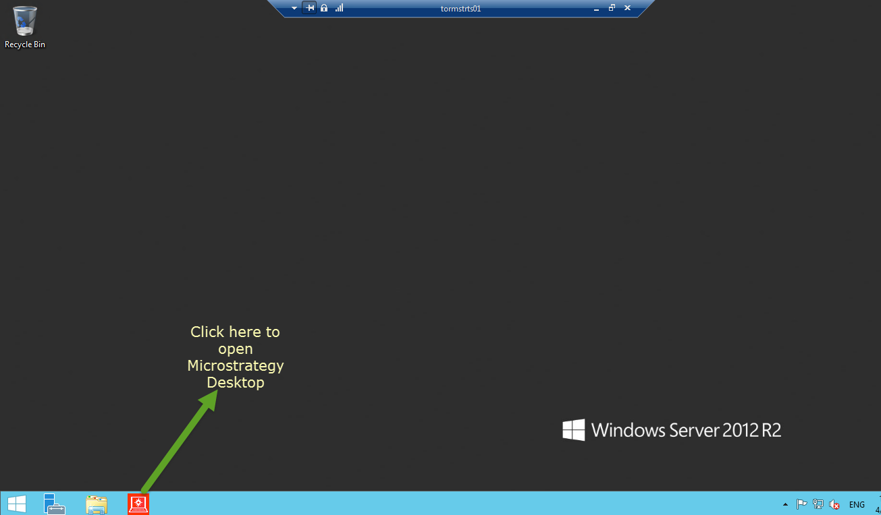

* Just click on red icon and the Micro Strategy Desktop will open.

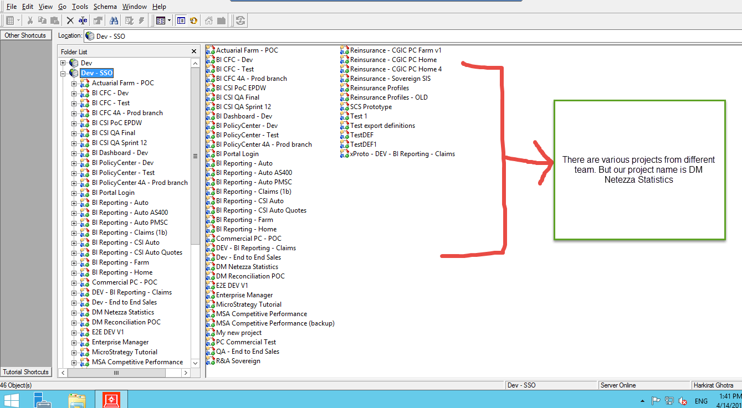

1. Create a project

* Project in MicroStrategy is the place, where we can create attributes, facts, metrics and reports for our dashboard in separate folders. Project name like (DM Netezza Stastics) tells that this project is for DM(Data management team )
* Just go to Dev-SSO -> right click-> then click on create project

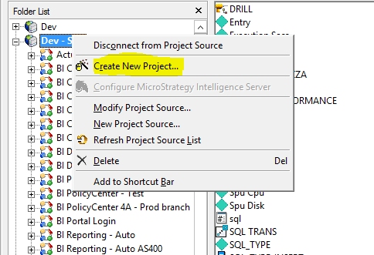

* You can create your new project, but only ADMIN can create you project, you will get an error that you don’t have privileges to create project. So, contact ADMIN, they will create new project.
* Our team has one project that is “DM Netezza Statistics”

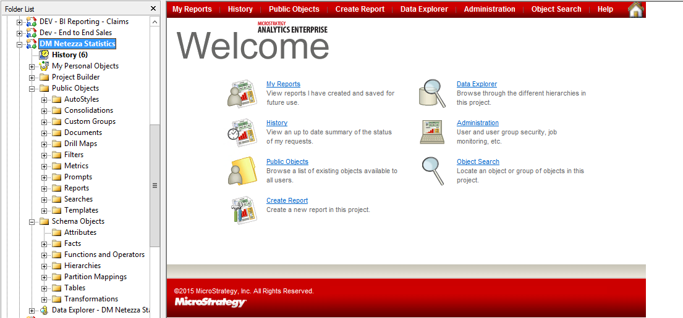

* We have different objects in our project. But we need to consider only two objects (public objects and Schema objects).
* In public objects, we can see “metrics”, “reports”, “filters” folders, I have used these folders and saved different metrics, reports in respective folders.

1. Create an Attributes

* Next step is to start creating attributes. So first create your Architect.
* Architect: In architect, we plan and design connection between attributes. There are two views one is Hierarchy view and another is project table view. Hierarchy view is used for making relationship between attributes and facts and project table view is used for viewing tables which you have in your project.
* If you want any other database or any other table from Netezza, just ask Admin (John Lauro), he will create database instance for you because we don’t have privilege.
* Just go to Schema -> then click on Architect

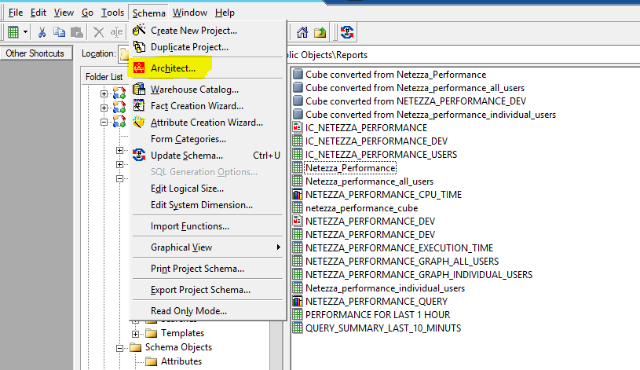

* Just Click the Architect option and you can build your own architect. Once it opens, it will show you “project table view and Hierarchy view”. This is the project table view, I have asked for three tables (HISTDBV3, NZ_STATS, and SYSTEM).
* Once we drag the table into the window, it automatically selects attributes and facts from table.
* If you want any database instance for you project to get data from any other databases, just contact ADMIN because we don’t have access to set up any database instance. Just create incident for particular table (for example, I did for NZ_STATS) and assign to John Lauro. He will provide the particular table in MicroStrategy.

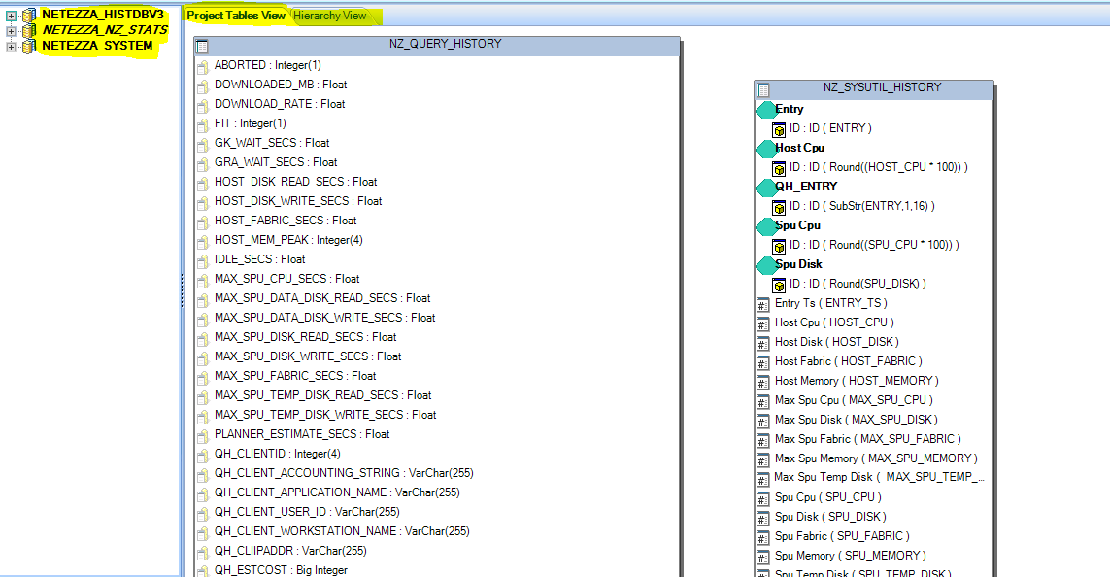

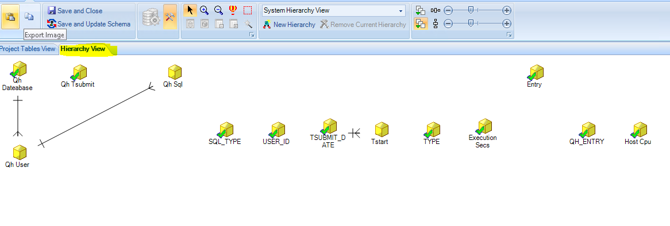

* This is the Hierarchy view, we can create child to parent relationship in this, but in my project, I didn’t use hierarchy because I didn’t get any access for “drill option”.
* Once the Architect is ready, it will automatically show which columns are attributes and which others are facts.
* If you want to change the attributes like provide some expression in attribute, you can do it manually.
* Just click on ATTRIBUTE folder and then right click on screen, just go to -> new -> new attributes

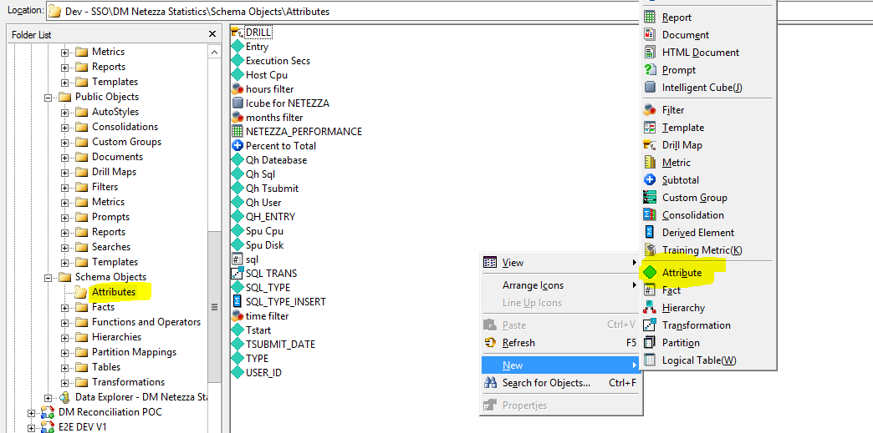

* You can see, there are many attributes, which have been created for report. Attributes are always visible in blue color.
* After that just click on Attribute and new form page will open.
* That new form is for creating new attribute with expression.

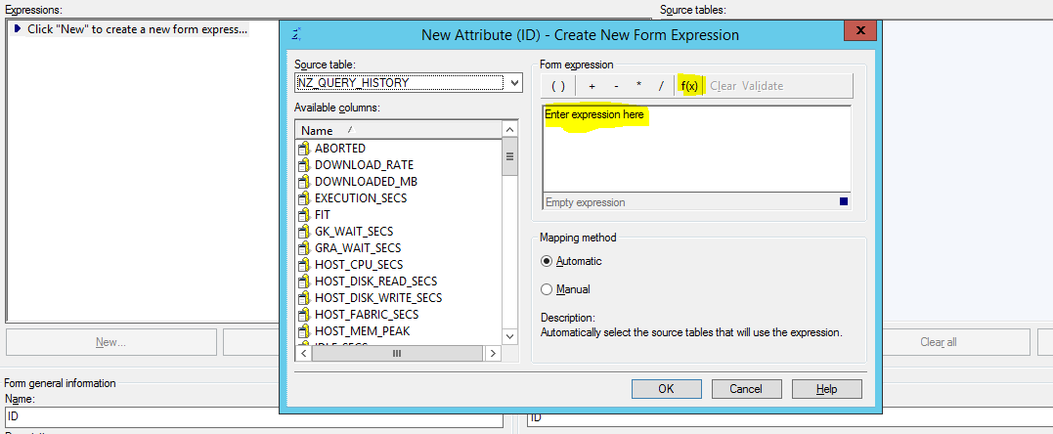

* Then, you can write any expression in place of “enter expression here”. For example, I have used one expression.

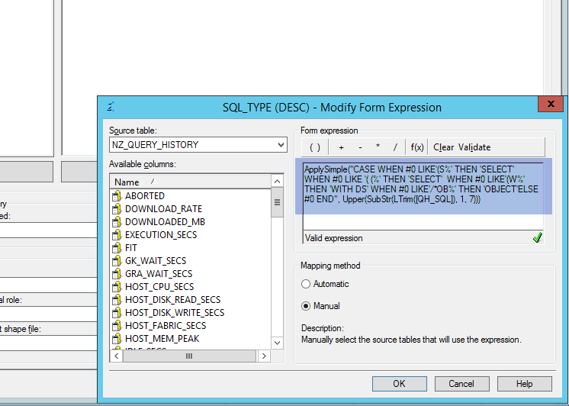

* In my report, I have used two attributes and three metrics.
* Attributes : SQL_TYPE and USER_ID

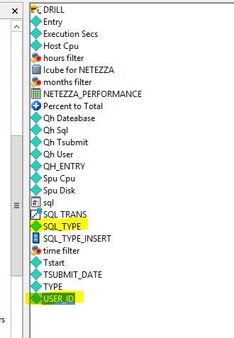

* For SQL_TYPE, I have used “ApplySimple” expression, because I wanted to separate some SQL_TYPE format.

Expression:

“ApplySimple("CASE WHEN #0 LIKE'(S%' THEN 'SELECT' WHEN #0 LIKE '( (%' THEN 'SELECT' WHEN #0 LIKE'(W%' THEN 'WITH DS' WHEN #0 LIKE'/*OB%' THEN 'OBJECT'ELSE #0 END", Upper(SubStr(LTrim([QH_SQL]), 1, 7)))”

* For USER_ID, I have used another expression

“Upper(SubStr([QH_USER], 1, 8))”



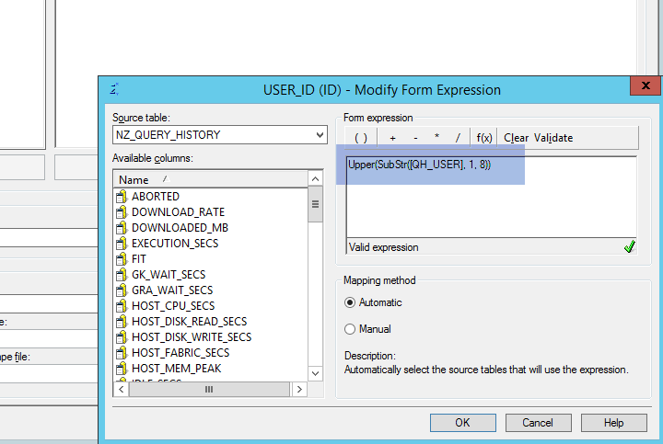

* Sometime, we need to create manual attributes because all the attributes we get from Architect are only showing simple expression. But in some case, we need attribute where we need only first 7 characters, so for that we use manual attributes.
* In my attributes, I used manual one and put my own expression in it.

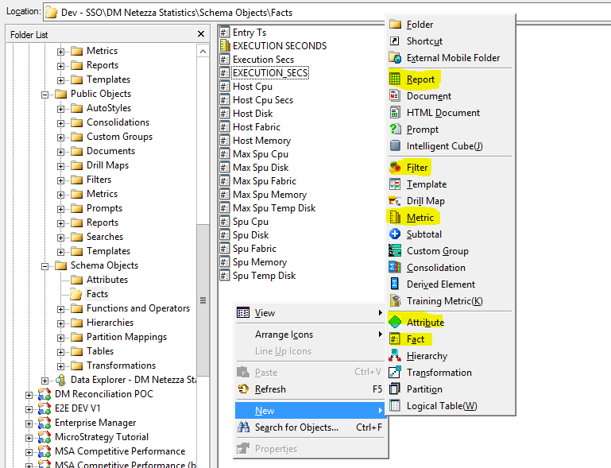

* We can use same way what we did in creating attribute to make facts, filters and metrics.

1. Create a Facts

* Just right click on screen -> go to new -> and click on facts. A new window will pop up.

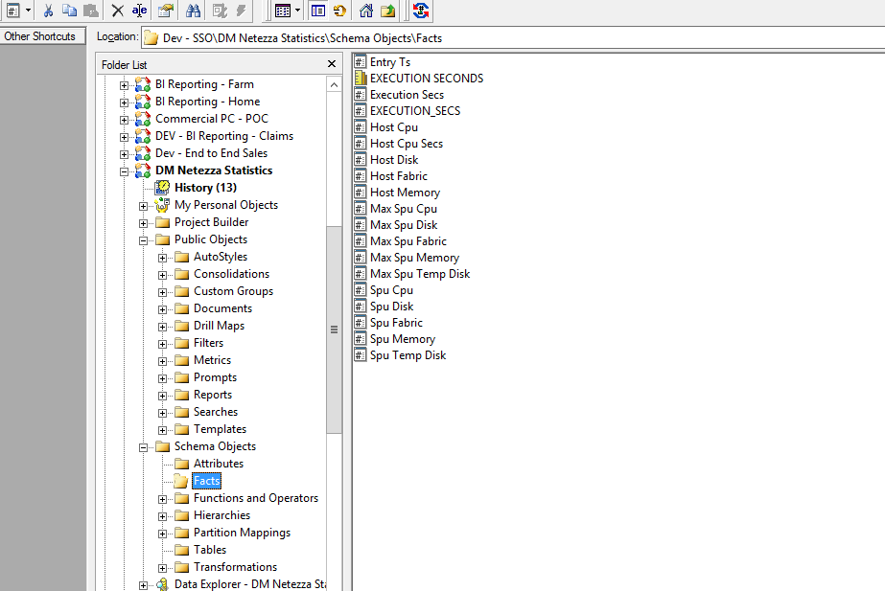

* These all are the facts, which have been created for reports, but I have used two facts i.e. Execution secs, Host Cpu

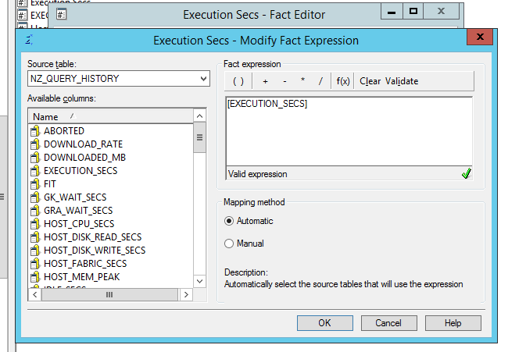

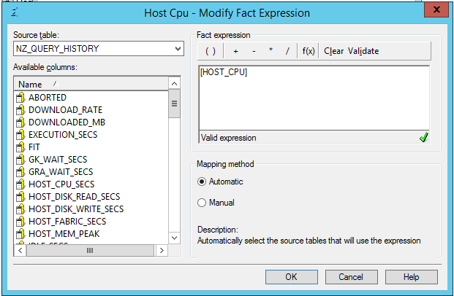

1. Create a Metrics

* Metrics are the important object as it defines the purpose of report. Metrics always use facts.
* Steps are same just right click on screen -> click on metrics-> select empty metrics->use formula to create metrics.

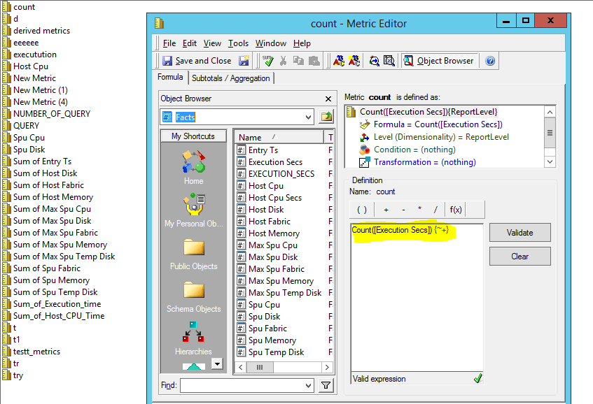

1. Create a report

* Once, everything is ready, like attributes, facts, metrics and filters, the next step is to create a “report”.
* To create new report, the step is same as what we have done for attributes. After clicking report in “public object folder”, “new grid” box will open.

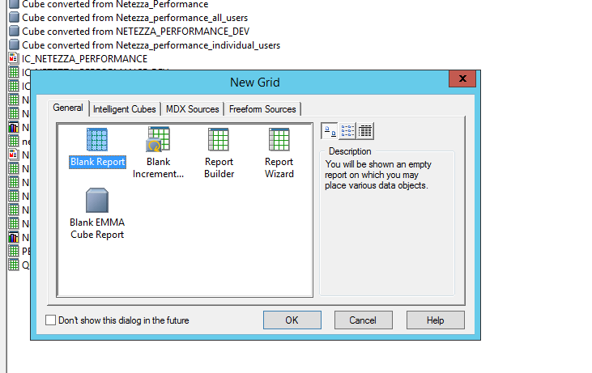

* After we click on ok, our report opens and we can drag and drop the attributes, filters and metrics to make reports

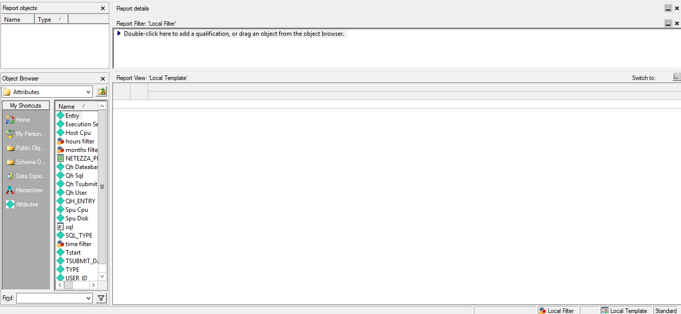

* Just drag and drop the attributes, metrics into the report and you can do it from left hand side option, where we have public object, schema object and can select attributes and metrics. Only drag attributes and metrics, not facts because metrics are made up of facts.
* Once, you drag and drop, just run the report by clicking on the left most icon, as shown in picture.

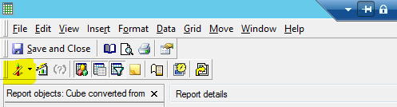

* Once the report run, we get our result from database.

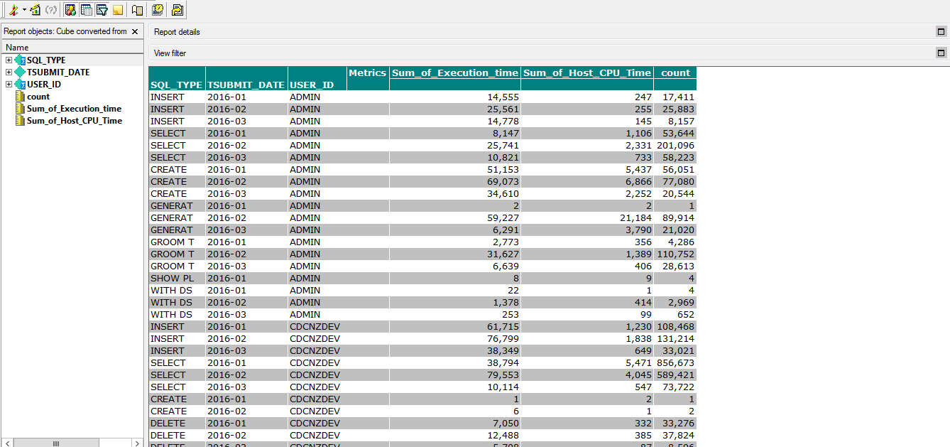

* Always save the report in report folder, otherwise, it will not be visible in shared report in MICROSTARETGY WEB.
* Once we have created the desire report, our next step is to start working with dashboard.

1. Create a dashboard

* There is two ways, we can create dashboard, one is by using micro strategy web and another is micro strategy desktop. I have created layout for dashboard in micro strategy desktop and run the dashboard in micro strategy web.
* Steps are same, just right click on screen -> go to new-> click on document. The box will show up and in that box just click on dashboard.

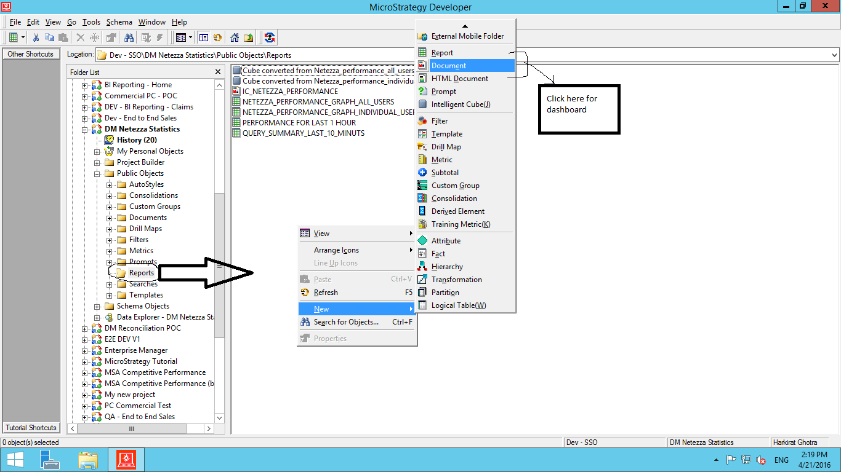

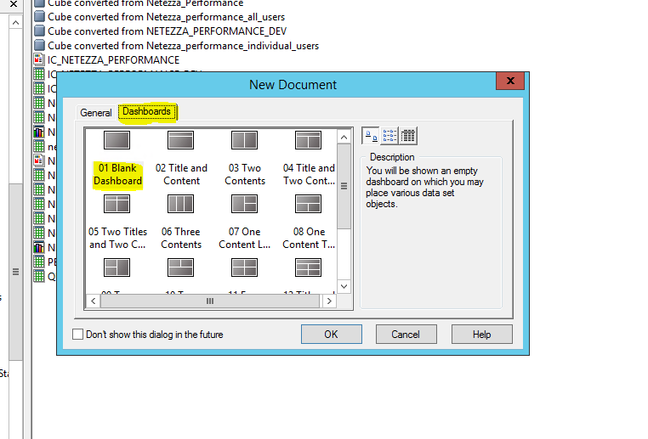

* Then we can choose our report from report folder, then the dashboard layout will open. We can customize our dashboard, like we can add panels, text box, image box etc.
* I have customized the dashboard and give my own style to it.

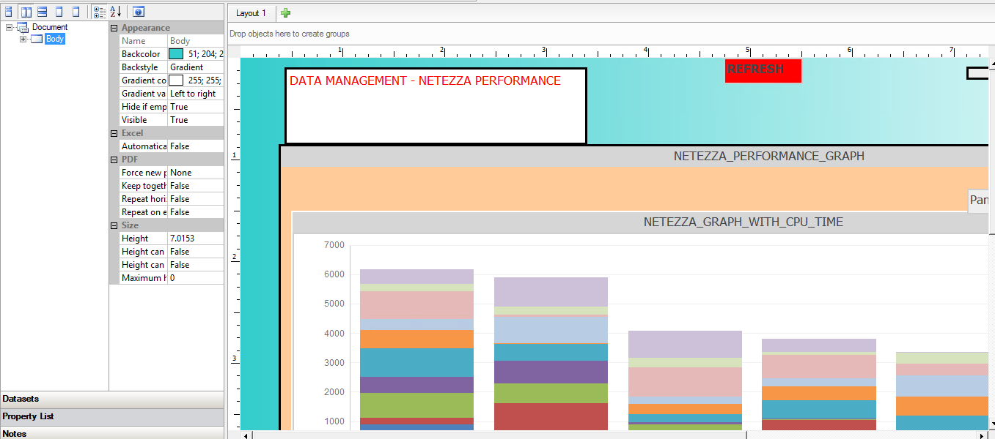

**Micro Strategy Web**

It’s a web version of micro strategy, where we can run our dashboard. One should always save reports in reports folder, so those reports will be visible in shared report folder of micro strategy Web.

Steps for using Micro Strategy Web

1. Choose our Project from home screen of Micro Strategy Web

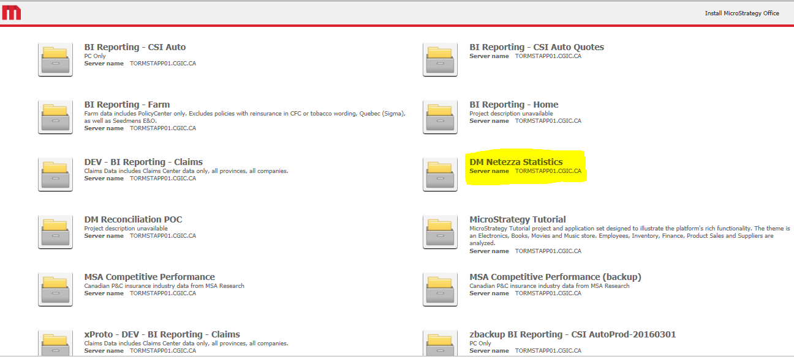

* Just choose the project name “DW Netezza Statistics”, which is our project name. Then our project will open.

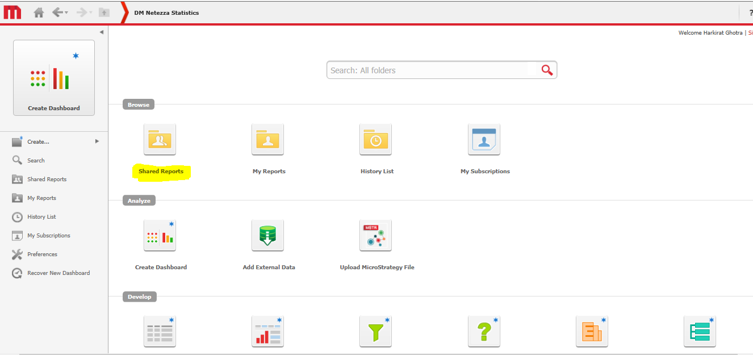

* Then just click on shared report and you will see all the report and document in shared report.

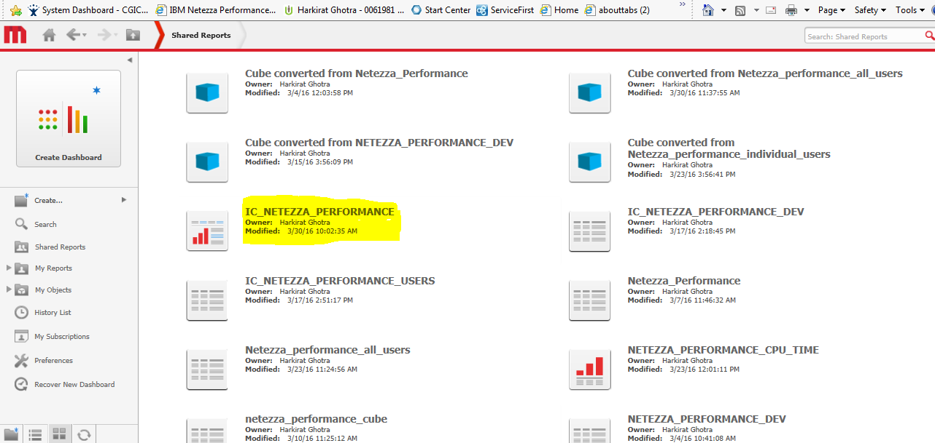

* Just click on “IC_NETEZZA_PERFORMANCE” and our dashboard will run.

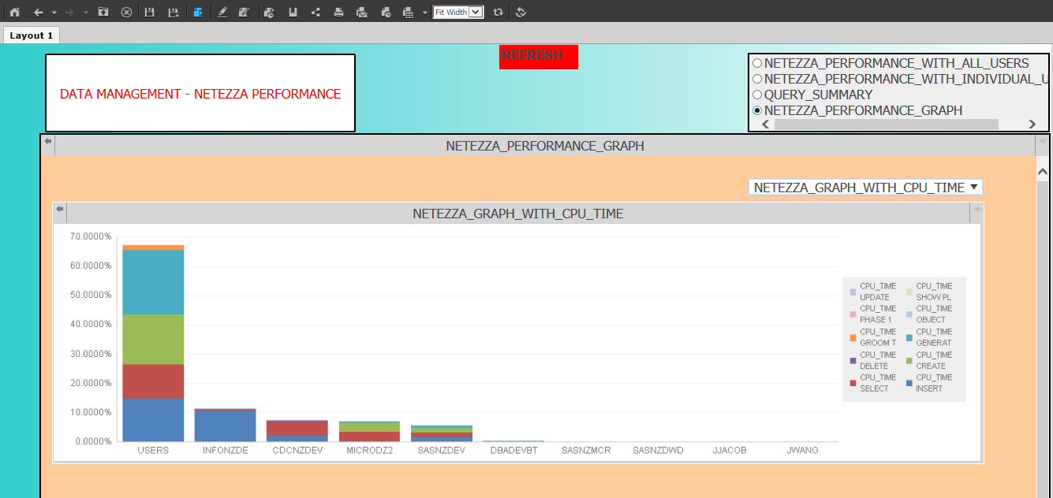

* This steps only tells you, how you can use both tools ( desktop as well as web)

In another documentation, I am going to explain my work, how did I create dashboard.

Thanks

Harkirat Ghotra